**Daily Change in Settlement (Bps)**

The following histograms illustrate the daily change in settlement of ED futures in the past 5 years.

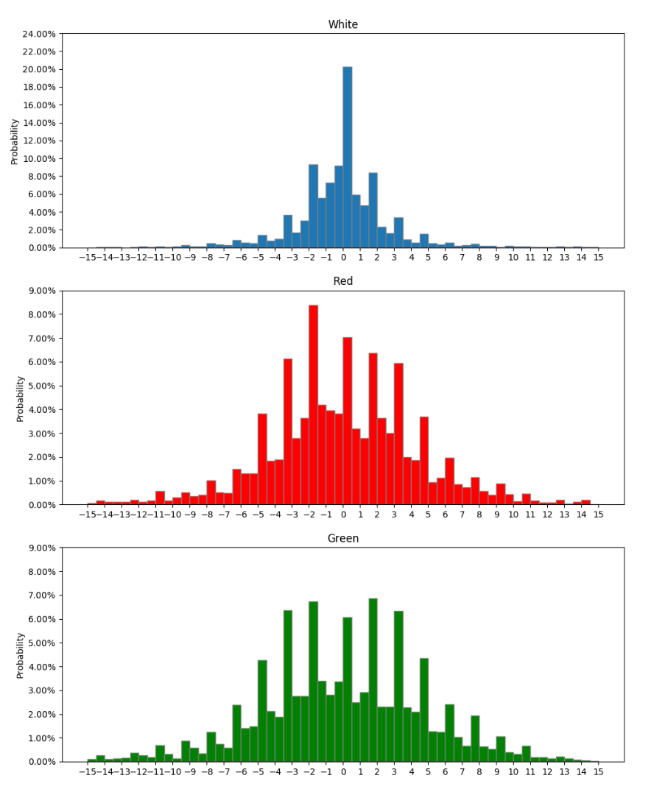

|  |  |  |
| --- | --- | --- |
|  | >10bp | < -10bp |
| Between -2bp to 2bp | 36.67% | 57.45% |
| Between -5bp to 5bp | 65.00% | 76.60% |
| Less than -5bp | 21.67% | 2.13% |
| Less than -10bp | 10.00% | 0.00% |
| More than 5bp | 15.00% | 14.89% |
| More than 10bp | 6.67% | 6.38% |
| Average move | -0.86bp | 1.16bp |

1 Day after a more than 10bp daily move in both direction, rates does not move much in Whites, Reds, and Greens as seen below:

**White:** Rates move 1 day after more than 10bp and less than -10bp move

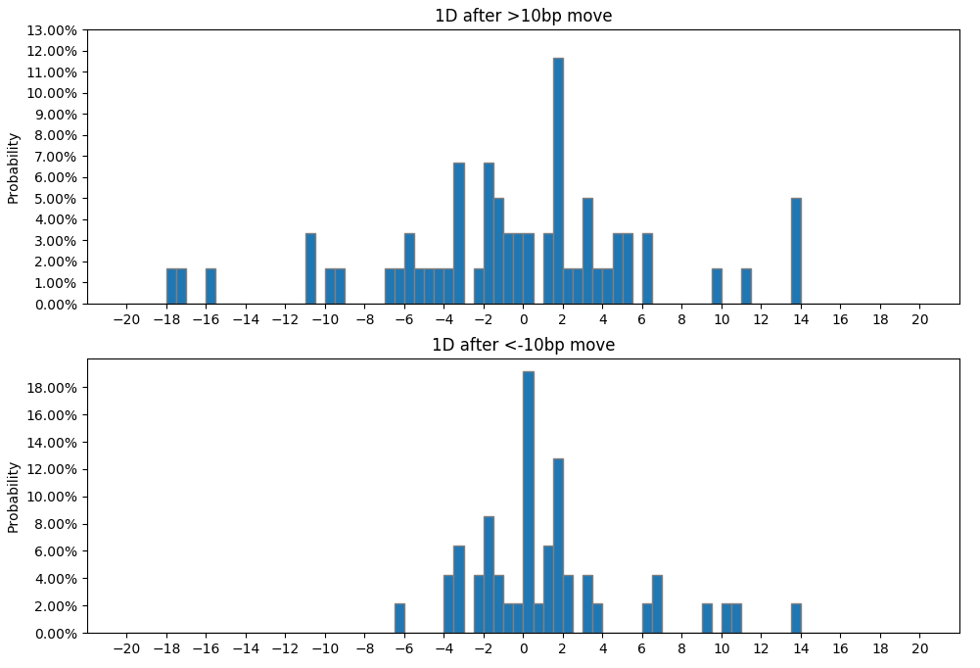

|  |  |  |
| --- | --- | --- |
|  | >10bp | <-10bp |
| Between -2bp to 2bp | 40.00% | 57.45% |
| Between -5bp to 5bp | 66.67% | 82.98% |
| Less than -5bp | 21.67% | 2.13% |
| More than 5bp | 11.67% | 14.89% |
| Less than -10bp | 10.00% | 0.00% |
| More than 10bp | 6.67% | 6.38% |
| Average move | -0.86bp | -1.16bp |

**Red:** Rates move 1 day after more than 10bp and less than -10bp move

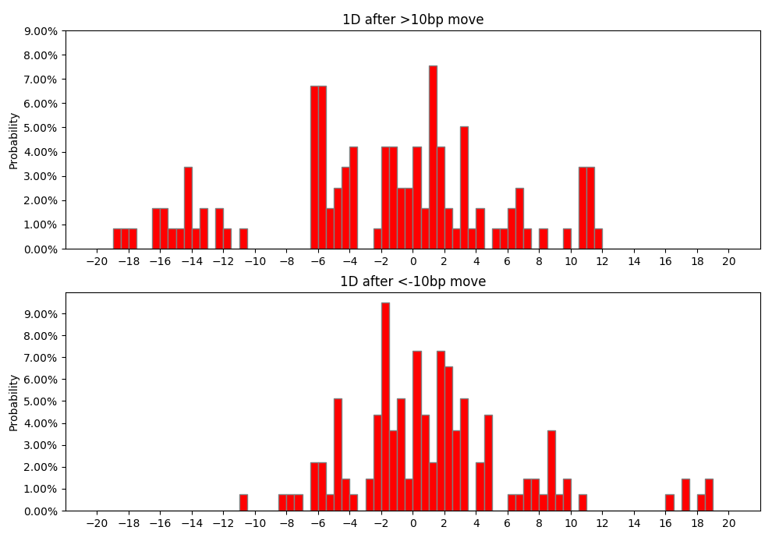

|  |  |  |
| --- | --- | --- |
|  | >10bp | < -10bp |
| Between -2bp to 2bp | 31.93% | 41.61% |
| Between -5bp to 5bp | 52.94% | 77.37% |
| Less than -5bp | 35.29% | 8.03% |
| More than 5bp | 11.76% | 14.60% |
| Less than -10bp | 20.17% | 0.73% |
| More than 10bp | 7.56% | 5.11% |
| Average move | -2.74bp | 1.39bp |

**Green:** Rates move 1 day after more than 10bp and less than -10bp move

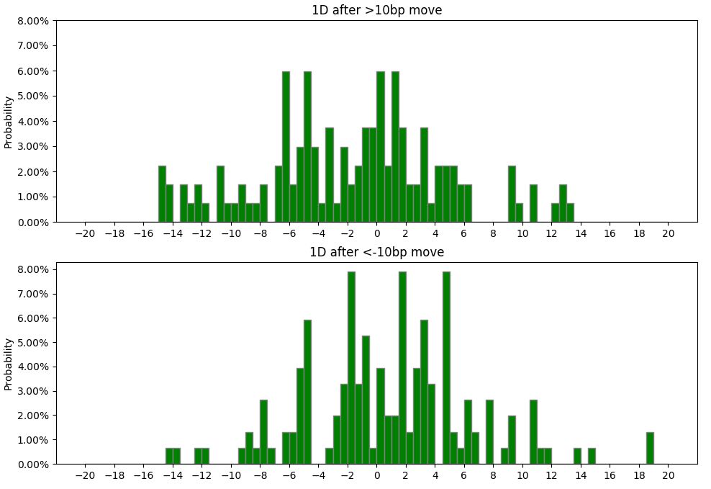

|  |  |  |
| --- | --- | --- |
|  | >10bp | <-10bp |
| Between -2bp to 2bp | 30.60% | 32.89% |
| Between -5bp to 5bp | 59.70% | 67.11% |
| Less than -5bp | 29.85% | 15.13% |
| More than 5bp | 10.45% | 17.76% |
| Less than -10bp | 11.94% | 2.63% |
| More than 10bp | 4.48% | 6.58% |
| Average move | -1.81bp | 0.85bp |

When rates move more than 10bps

|  |  |  |  |
| --- | --- | --- | --- |
|  | Probability it moves < -10 bp  after a > 10bp move | | |
| Number of days after | White | Red | Green |
| 1 | 10.00% | 20.17% | 11.94% |
| 2 | 28.07% | 30.51% | 16.42% |
| 3 | 28.07% | 28.81% | 13.64% |
| 4 | 31.57% | 36.44% | 31.06% |
| 5 | 29.82% | 37.29% | 28.79% |
| 6 | 33.33% | 38.14% | 21.97% |
| 7 | 29.82% | 38.14% | 28.03% |
| 8 | 31.58% | 33.90% | 26.52% |
| 9 | 28.07% | 32.20% | 18.94% |
| 10 | 26.32% | 31.36% | 28.03% |
| 11 | 29.82% | 37.29% | 25.00% |
| 12 | 31.58% | 40.68% | 34.09% |
| 13 | 31.58% | 37.29% | 34.85% |
| 14 | 35.09% | 36.44% | 26.15% |
| 15 | 38.60% | 38.98% | 31.82% |
| 16 | 40.35% | 43.22% | 29.55% |
| 17 | 43.86% | 44.92% | 31.82% |
| 18 | 43.39% | 44.92% | 28.46% |
| 19 | 42.11% | 50.00% | 37.69% |
| 20 | 40.35% | 46.61% | 38.28% |
| 21 | 40.25% | 44.07% | 37.50% |

When rates move less than -10bps

|  |  |  |  |
| --- | --- | --- | --- |
|  | Probability it moves > 10 bp  after a < -10bp move | | |
| Number of days after | White | Red | Green |
| 1 | 6.38% | 5.11% | 6.58% |
| 2 | 8.51% | 11.85% | 7.38% |
| 3 | 10.64% | 17.04% | 14.09% |
| 4 | 10.64% | 15.56% | 17.45% |
| 5 | 23.40% | 22.96% | 22.82% |
| 6 | 19.15% | 26.67% | 28.19% |
| 7 | 17.02% | 22.96% | 30.20% |
| 8 | 27.66% | 28.15% | 27.52% |
| 9 | 34.04% | 29.63% | 25.50% |
| 10 | 23.40% | 33.33% | 28.85% |
| 11 | 29.79% | 27.41% | 30.87% |
| 12 | 29.79% | 32.59% | 31.54% |
| 13 | 25.53% | 28.15% | 34.23% |
| 14 | 31.91% | 30.37% | 32.21% |
| 15 | 29.79% | 31.85% | 34.90% |
| 16 | 27.66% | 34.81% | 34.90% |
| 17 | 27.66% | 34.81% | 32.89% |
| 18 | 29.79% | 31.85% | 29.53% |
| 19 | 31.91% | 28.15% | 24.83% |
| 20 | 29.79% | 29.63% | 30.20% |
| 21 | 31.91% | 34.07% | 35.57% |

**2 days after a more than 10bp daily move in both directions**

White:

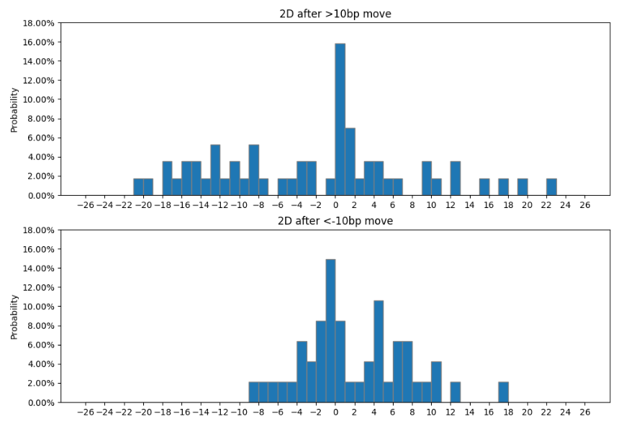

|  |  |  |
| --- | --- | --- |
| White | >10bp | < -10bp |
| Between -2bp to 2bp | 24.56% | 34.04% |
| Between -5bp to 5bp | 42.11% | 63.83% |
| Less than -5bp | 38.60% | 8.51% |
| Less than -10bp | 28.07% | 0.00% |
| More than 5bp | 19.30% | 27.66% |
| More than 10bp | 12.28% | 8.51% |

Red:

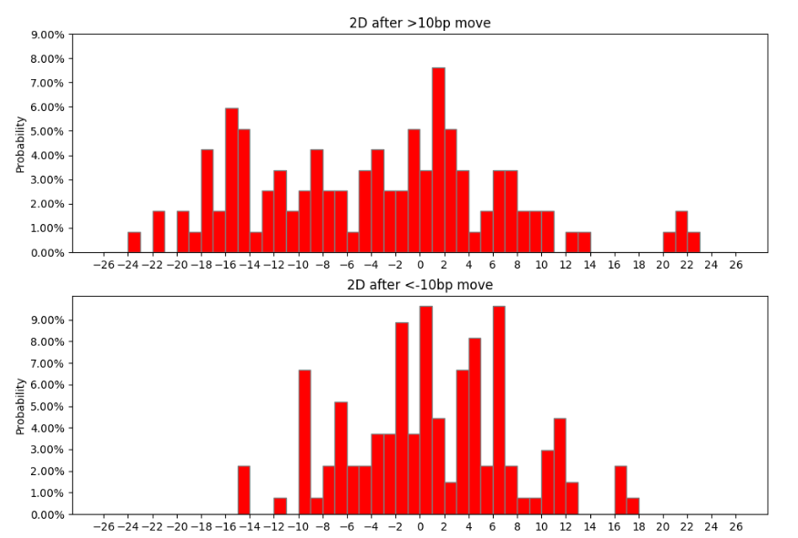

|  |  |  |
| --- | --- | --- |
|  | >10bp | < -10bp |
| Between -2bp to 2bp | 18.64% | 26.67% |
| Between -5bp to 5bp | 38.14% | 52.59% |
| Less than -5bp | 43.22% | 20.00% |
| Less than -10bp | 30.51% | 2.96% |
| More than 5bp | 18.64% | 27.41% |
| More than 10bp | 6.78% | 11.85% |

Green:

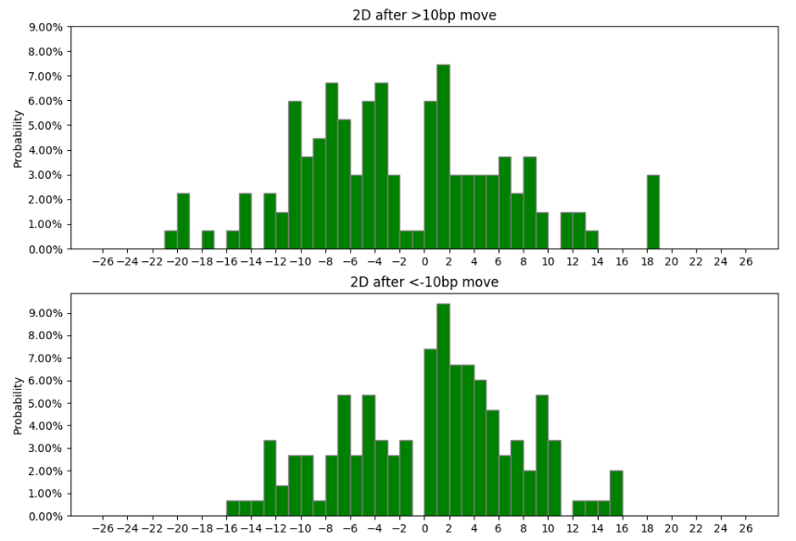

|  |  |  |
| --- | --- | --- |
|  | >10bp | < -10bp |
| Between -2bp to 2bp | 14.93% | 20.13% |
| Between -5bp to 5bp | 39.55% | 51.01% |
| Less than -5bp | 39.55% | 23.49% |
| Less than -10bp | 16.42% | 9.40% |
| More than 5bp | 20.90% | 25.50% |
| More than 10bp | 6.72% | 7.38% |

**4 days after a more than 10bp daily move in both directions**

White:

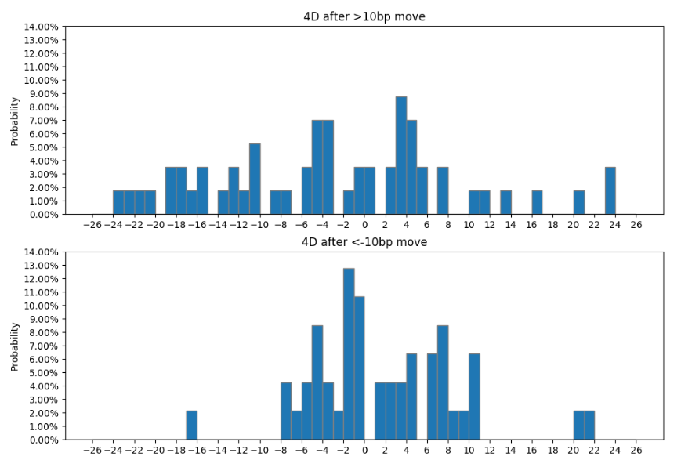

|  |  |  |
| --- | --- | --- |
|  | >10bp | < -10bp |
| Between -2bp to 2bp | 8.77% | 27.66% |
| Between -5bp to 5bp | 42.11% | 57.45% |
| Less than -5bp | 38.60% | 12.77% |
| Less than -10bp | 31.57% | 21.28% |
| More than 5bp | 19.30% | 29.79% |
| More than 10bp | 12.28% | 10.64% |

Red:

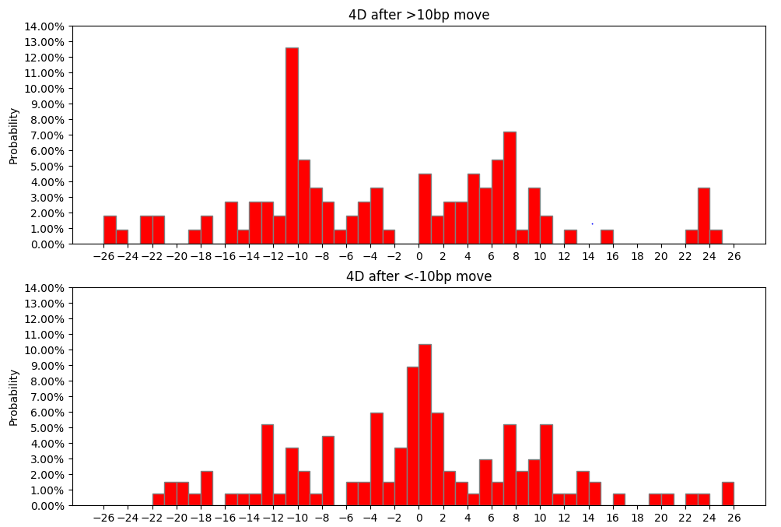

|  |  |  |
| --- | --- | --- |
|  | >10bp | < -10bp |
| Between -2bp to 2bp | 5.93% | 28.89% |
| Between -5bp to 5bp | 22.03% | 42.22% |
| Less than -5bp | 50.00% | 27.41% |
| Less than -10bp | 36.44% | 18.52% |
| More than 5bp | 27.97% | 30.37% |
| More than 10bp | 8.47% | 15.56% |

Green:

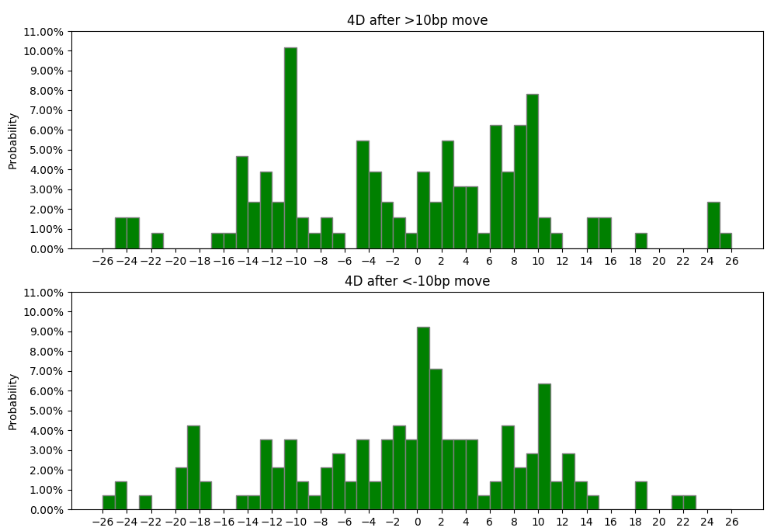

|  |  |  |
| --- | --- | --- |
|  | >10bp | < -10bp |
| Between -2bp to 2bp | 8.33% | 22.82% |
| Between -5bp to 5bp | 31.06% | 40.94% |
| Less than -5bp | 35.61% | 30.87% |
| Less than -10bp | 31.06% | 22.82% |
| More than 5bp | 33.33% | 28.19% |
| More than 10bp | 9.09% | 17.45% |

**10 trading days (approximately 2weeks) after a more than 10bp daily move in both directions**

White:

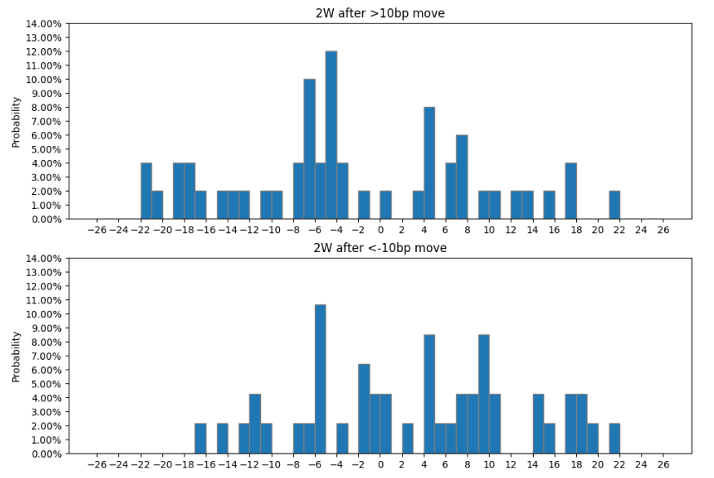

|  |  |  |
| --- | --- | --- |
|  | >10bp | < -10bp |
| Between -2bp to 2bp | 3.51% | 14.89% |
| Between -5bp to 5bp | 26.32% | 27.66% |
| Less than -5bp | 43.86% | 27.66% |
| Less than -10bp | 26.32% | 12.77% |
| More than 5bp | 29.82% | 44.68% |
| More than 10bp | 19.30% | 23.40% |

Red:

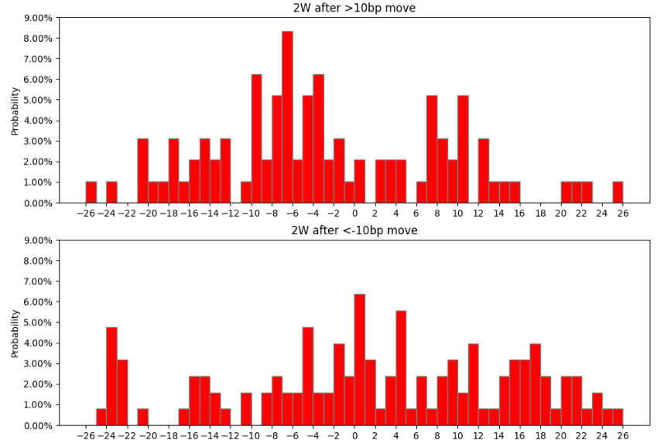

|  |  |  |
| --- | --- | --- |
| Red | >10bp | < -10bp |
| Between -2bp to 2bp | 5.08% | 14.81% |
| Between -5bp to 5bp | 21.19% | 30.37% |
| Less than -5bp | 50.85% | 27.41% |
| Less than -10bp | 31.36% | 20.74% |
| More than 5bp | 27.97% | 42.22% |
| More than 10bp | 18.64% | 33.33% |

Green:

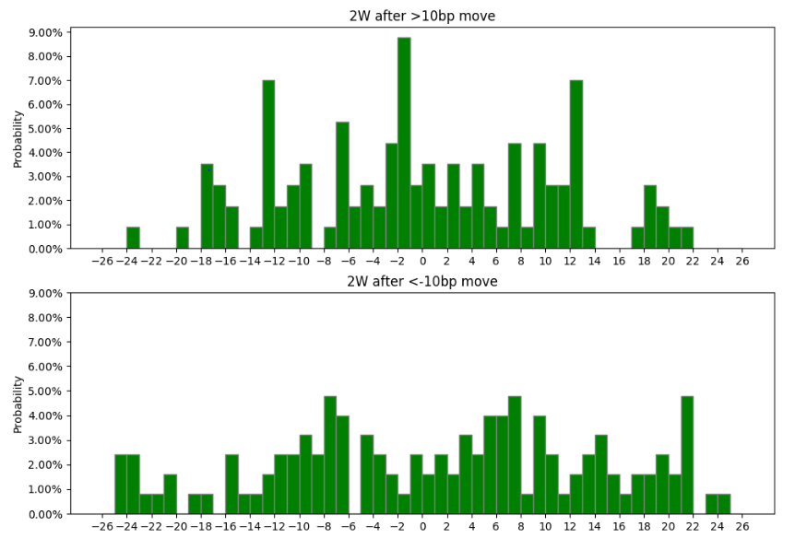

|  |  |  |
| --- | --- | --- |
|  | >10bp | < -10bp |
| Between -2bp to 2bp | 14.39% | 6.04% |
| Between -5bp to 5bp | 29.55% | 18.12% |
| Less than -5bp | 37.88% | 38.26% |
| Less than -10bp | 28.03% | 26.17% |
| More than 5bp | 32.58% | 43.62% |
| More than 10bp | 21.97% | 28.85% |

**15 trading days (approximately 3weeks) after a more than 10bp daily move in both directions**

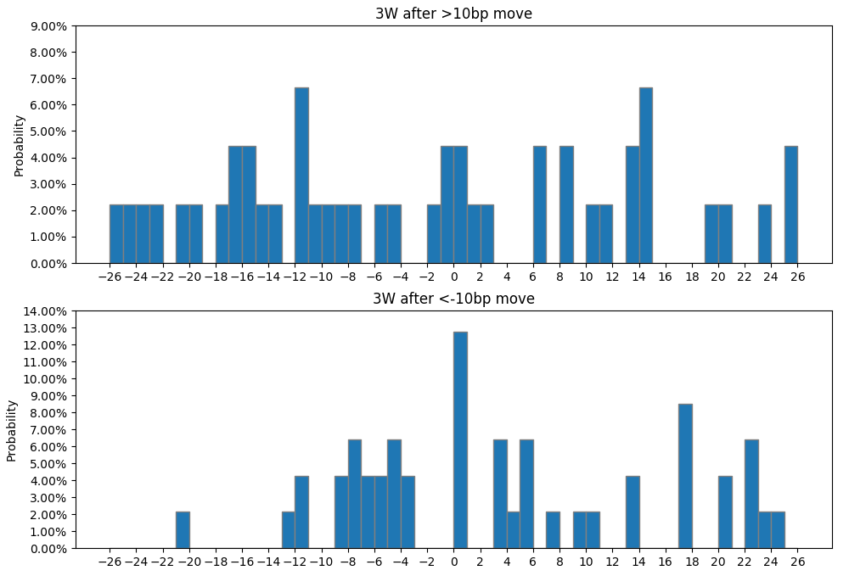

|  |  |  |
| --- | --- | --- |
|  | >10bp | < -10bp |
| Between -2bp to 2bp | 10.53% | 12.77% |
| Between -5bp to 5bp | 14.04% | 31.91% |
| Less than -5bp | 45.61% | 27.66% |
| Less than -10bp | 38.60% | 8.51% |
| More than 5bp | 40.35% | 40.04% |
| More than 10bp | 33.33% | 29.79% |

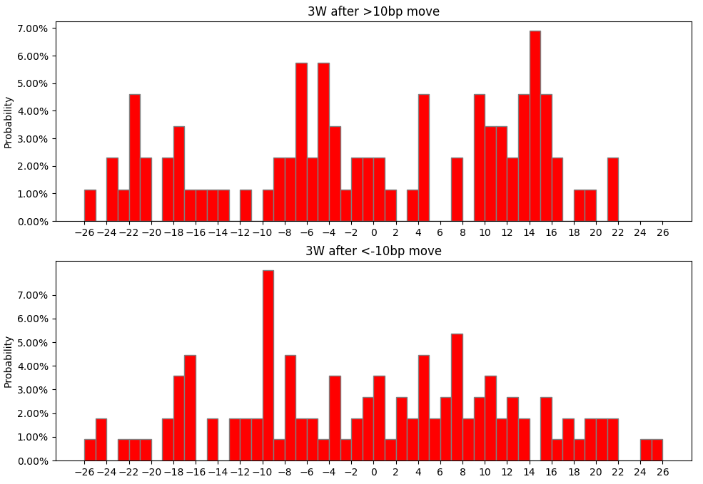

|  |  |  |
| --- | --- | --- |
|  | >10bp | < -10bp |
| Between -2bp to 2bp | 5.93% | 7.41% |
| Between -5bp to 5bp | 17.80% | 19.26% |
| Less than -5bp | 49.15% | 37.04% |
| Less than -10bp | 38.98% | 22.96% |
| More than 5bp | 33.05% | 43.70% |
| More than 10bp | 27.97% | 31.85% |

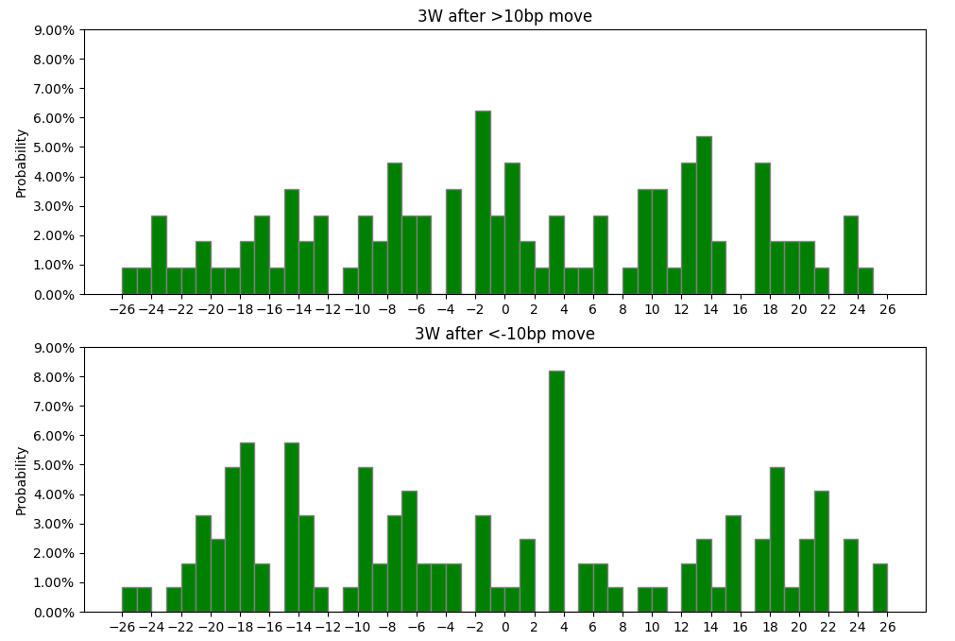

|  |  |  |
| --- | --- | --- |
|  | >10bp | < -10bp |
| Between -2bp to 2bp | 12.88% | 6.06% |
| Between -5bp to 5bp | 19.70% | 15.44% |
| Less than -5bp | 43.94% | 45.64% |
| Less than -10bp | 31.82% | 32.89% |
| More than 5bp | 36.36% | 38.93% |
| More than 10bp | 29.55% | 34.90% |